Investigating a Novel Combination of Treatments for MS Patients

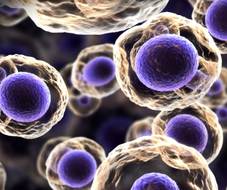

Frequently prescribed MS treatments are prescribed with the goal of disease stabilization. However, they may share a common deficiency, lack of effectiveness in addressing the symptoms of the disease. Additionally they may lead to a troubling array of side effects which in themselves can negatively impact quality of life.
Newer treatments are now being investigated that seek to address the most debilitating MS symptoms. Since these novel therapies do not involve long-term treatment with pharmacological agents, they present a possible option for MS patients who are either unable to tolerate the side-effects of MS medications or who are unsatisfied with the results of their current therapies.
Dr. Michael Arata of Autonomic Specialists in Newport Beach, California has been investigating a therapeutic approach that targets many of the more troublesome symptoms of MS, particularly those related to autonomic dysfunction (including brain fog, fatigue, headaches upon awakening, bladder and bowel problems, and inability to thermoregulate). This endovascular therapy, called Transvascular Autonomic Modulation (TVAM), has been shown to improve symptoms in a majority of patients, according to research published in Acta Phlebologica.
More recently, Dr. Arata has been investigating a surgical treatment involving the use of adult mesenchymal stem cells in conjunction with the Cell Surgical Network. This treatment involves mesenchymal stem cells in a stromal vascular fraction (SVF) that is produced from the patient’s own fat cells (extracted via a mini-liposuction procedure).
Mesenchymal stem cells and growth factors contained in SVF are known to have strong anti-inflammatory properties. Mesenchymal stem cells also have the capacity to remain dormant until they reach an area of injured or damaged tissue.
Now Dr. Arata is investigating an approach for patients with MS that includes both TVAM therapy and the SVF/mesenchymal stem cell treatment in a single outpatient visit.
It is possible that including both mesenchymal stem cell therapy and the TVAM procedure may lead to an enhanced effect. Therapeutic synergy might be achieved through both the anti-inflammatory effects of the SVF and the reparative capabilities of mesenchymal stem cells along with enhanced autonomic function seen in patients following TVAM.

